Present Tense Artist Talks

Extra Credit

What
Present Tense Artist Talks are in-person, quarterly events hosted by Medium Photo, showcasing work from four selected photographers, who each share a short slideshow from one of their bodies of work in an informal conversational environment.

The selected photographers tend to be emerging or mid-career artists and we always have at least one student sharing their work. In a short amount of time, you will experience a variety of photographic perspectives, approaches, and aesthetics.

When
Present Tense #1
Saturday, April 27, 3:00–4:30 pm
in conjunction with the Medium Festival of Photography

Where
Courtyard by Marriott San Diego Old Town
2435 Jefferson St.,
San Diego, CA 92110
There will be a dedicated parking lot a block away from the event. The Old Town Transit Center is a 10-minute walk away and is served by the Blue and Green Trolley lines, Coaster, and Amtrak.

How Much
FREE
Present Tense Artist Talks are FREE to attend. If you’d like to register for additional Medium Festival programming, we offer generous student discounts.
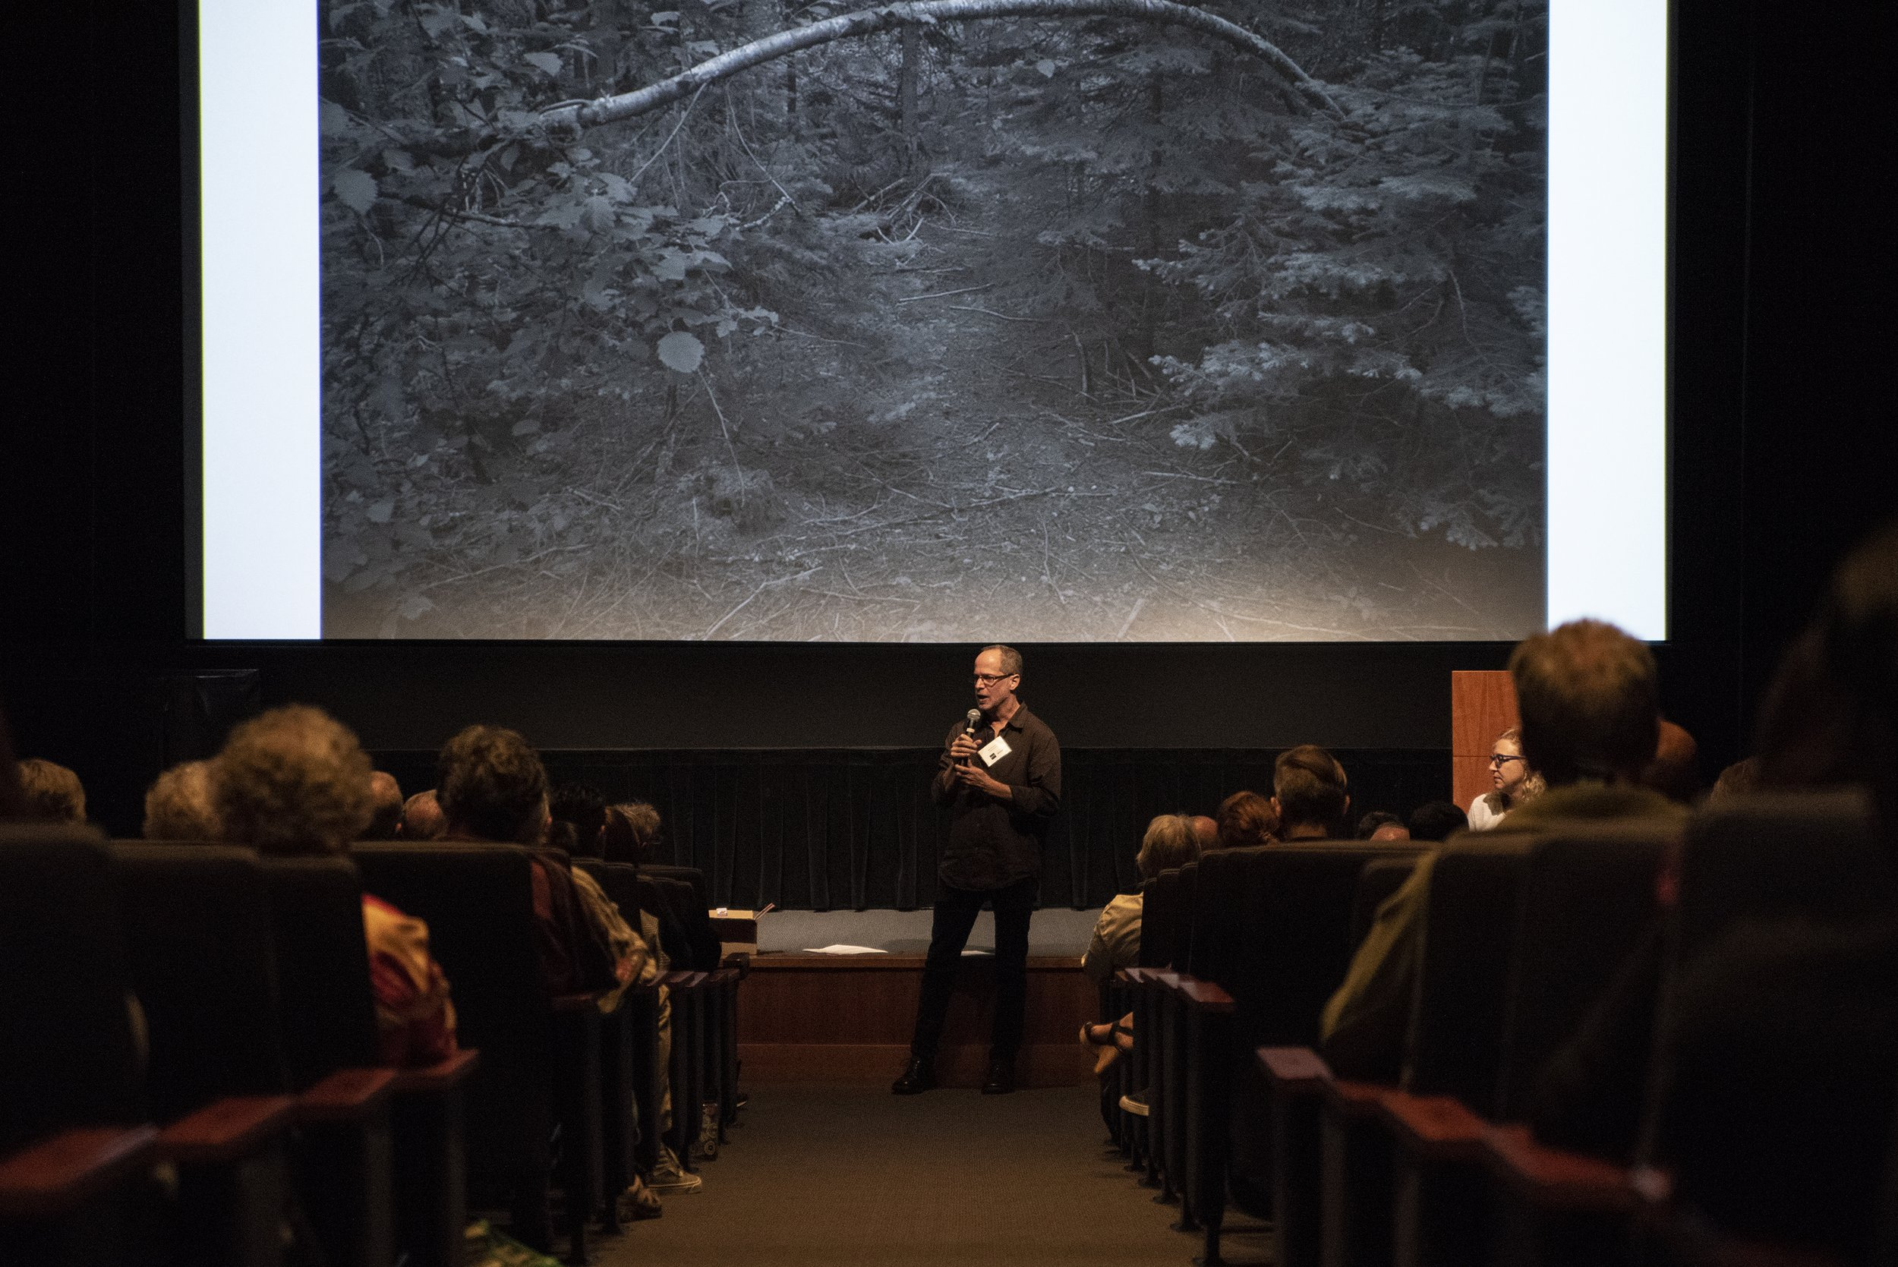

Information

In the space below, list the names of the four photographers who presented and their websites and/or social media.

Presenter 1 name: ______________________________ Website: ___________________________________

Presenter 2 name: ______________________________ Website: ___________________________________

Presenter 3 name: ______________________________ Website: ___________________________________

Presenter 4 name: ______________________________ Website: ___________________________________

Personal Response
- Which presenter’s work did you connect most strongly with and why?
- Choose another one of the presenters and write a description of their work to someone who wasn’t there. For example: what was their work about? who or what did they photograph? what made their work unique?
- Summarize what you learned from the experience of attending the Present Tense Artist Talks, including a description of how you can apply what you learned.
- Describe at least one specific moment during your experience that you want to remember beyond today, including why you believe it’s important to remember (for example, a nugget of wisdom shared by a presenter, an interaction you had with someone, a specific photograph or technique you saw).

